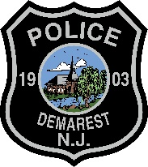
Demarest Police Department
Diversity in Law Enforcement Recruiting & Hiring Plan
(2022)

PURPOSE:
The goal of the Demarest Police Department Recruitment Plan is to attract qualified individuals to pursue a career with the Demarest Police Department through the departments recruiting activities. It is the intent and policy of this department to attract and employ qualified applicants who represent the racial and gender demographics of the residents of the Borough of Demarest. To that end, this agency will endeavor to set and meet specific goals to promote demographic consistency throughout the hiring process, as provided for in N.J.S.A. 52:17B-4.10 et seq. and corresponding New Jersey Attorney General Guidelines “Promoting Diversity in Law Enforcement Recruiting and Hiring” issued December 7, 2021.
Special emphasis shall be placed on achieving ethnic, racial, and gender workforce composition in the sworn law enforcement ranks in approximate proportion to the makeup of the available workforce in the Demarest Police Department.
The Demarest Police Department is an equal opportunity employer in all facets of the personnel process.

DEMOGRAPHIC DATA:
The demographics composition of the Borough of Demarest and the Demarest Police Department are represented in the following table:
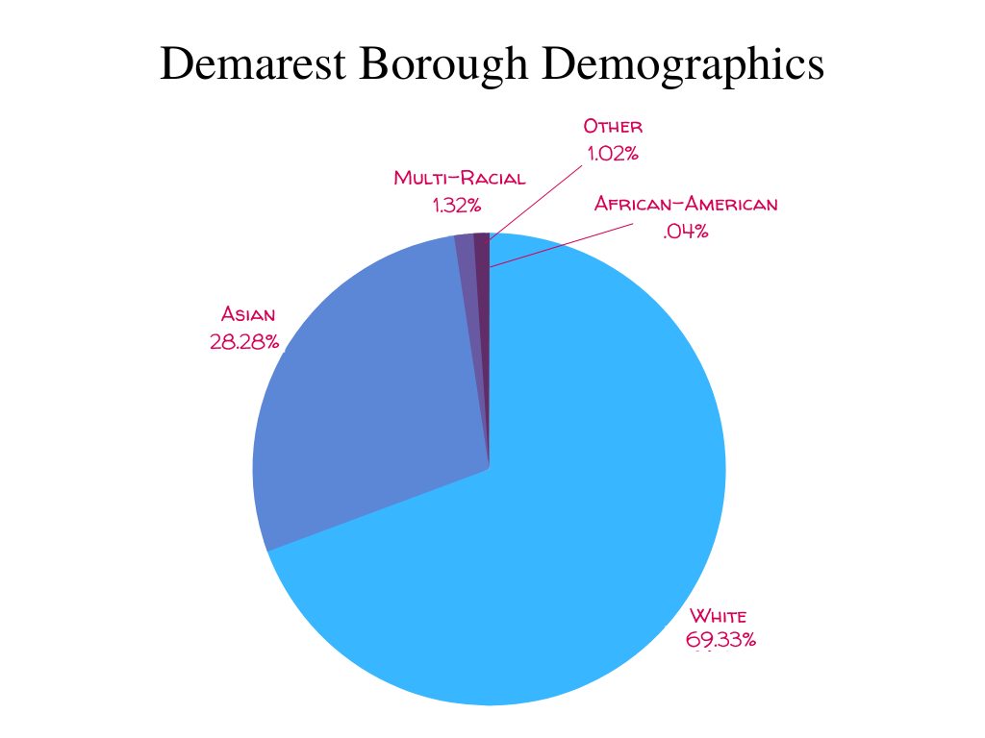

The 2020 Census indicates that the Borough of Demarest population is 69.33% White, 28.28% Asian, 0.04% Black or African American, 1.32% Two or more races, 1.02% Other race. As of September 1, 2022, the Demarest Police Department employed 17 sworn officers: 99% were white, 1% were Asian, 0% were black, 0% were Hispanic, 0% were female. Although our diversity numbers are fairly representative of the Borough we serve, we recognize our deficiency in representing the Black, Hispanic, and female population of our community. We will continue to strive to increase the number of diverse hires within our agency and will enhance our efforts to seek diverse applicants to join our agency. This will be accomplished through job fares, community outreach through our religious and educational organizations throughout our borough.

RECRUITMENT ACTIVIES:
- The Demarest Police Department seeks to hire from PTC certified and or current Alternate Route Program Applicants, as well as through our departmental Special’s Program.
- Make use of our Borough of Demarest website, our Police Department Website, Social Media pages and accounts to attract qualified candidates.
- Utilize the Borough of Demarest’s Electronic Sign Board for job postings and recruitment
- Advertise on PoliceApp.com, Police1.com, PoliceRecruiter.com, NJOfficer.com
- Share hiring announcements with various law enforcement-related organizations (NJ Women in Law Enforcement, NJ Asian Law Enforcement Officers Association, NJ Latino Officers Association)
- Community and faith-based events and recruiting initiatives held in conjunction with various educational and community-based organizations.
- Draft, print, and distribute informational brochures that may attract qualified candidates to the agency.
- Provide recruitment brochures and materials to educational, religious, ethnic, racial, and gender-based organizations.
- Contact the local Board of Education to seek permission to address high school students to interest them in a career with our agency following completion of their formal education.
- In person events such as blood drives, National Night Out, Military Appreciation events, and Coffee with a Cop will have recruitment flyers and hiring information available with officer’s present for questions and guidance in the application and hiring process.
- Create an innovative recruitment video that can be viewed via our social media platforms.

REVIEW, EVALUATION, AND REPORTING:

- The Chief of Police, or designee, shall conduct an annual review of the Recruitment Plan and shall include, but not limited to, performing an annual agency demographic review, determining whether any substantial disparities have been reduced, and if need be, revising the Recruitment Plan accordingly if the goals and objectives are not met.
- N.J.S.A. 52:17B-4.10 et seq requires that each law enforcement agency must report certain law enforcement applicant data annually by January 31st for the preceding year. The data required to be reported is listed in the New Jersey Attorney General Guideline “Promoting Diversity in Law Enforcement Recruiting and Hiring” in Paragraph III.

